**TUGAS UAS**

**REKAYASA PERANGKAT LUNAK**

**( SISTEM INFORMASI PRAMUKA )**



**Dosen Pengampu: La Ode Mohamad Zulfiqar, S.T.,M.Kom**

Disusun Oleh :

**Nama : M. Septian Parmansah**

**Kelas : 6A**

**NIM : 16090118**

**D-IV TEKNIK INFORMATIKA**

**POLITEKNIK HARAPAN BERSAMA TEGAL**

**2019**

1. **WhiteBox**
2. Gambar Flowchart Admin

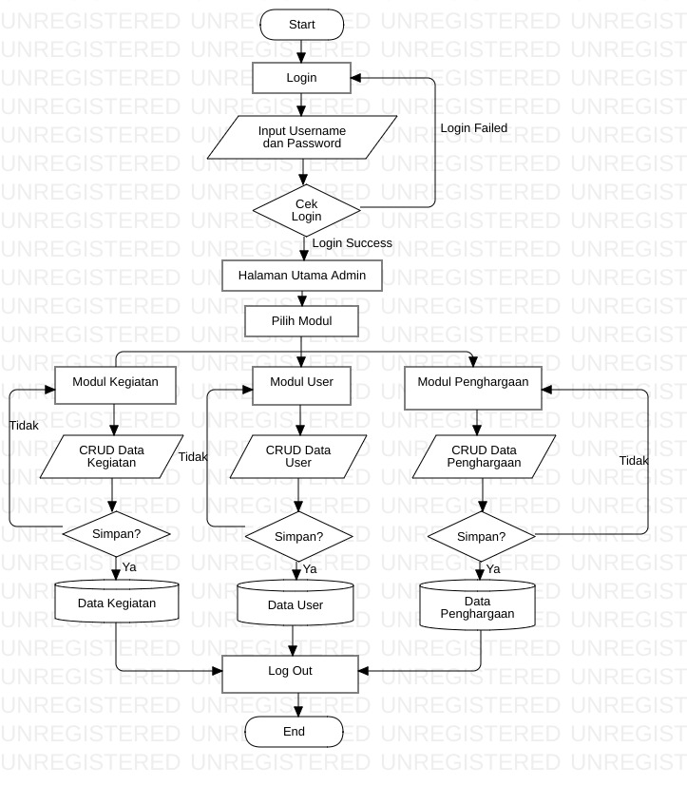

1. Gambar Flowchart User

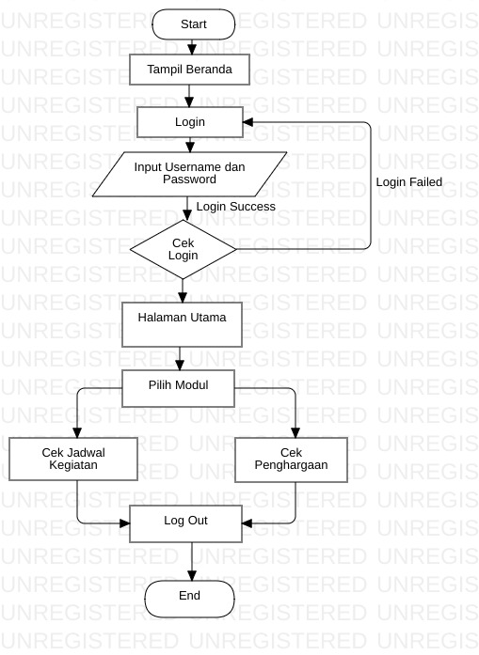

1. Gambar Flowchart Register

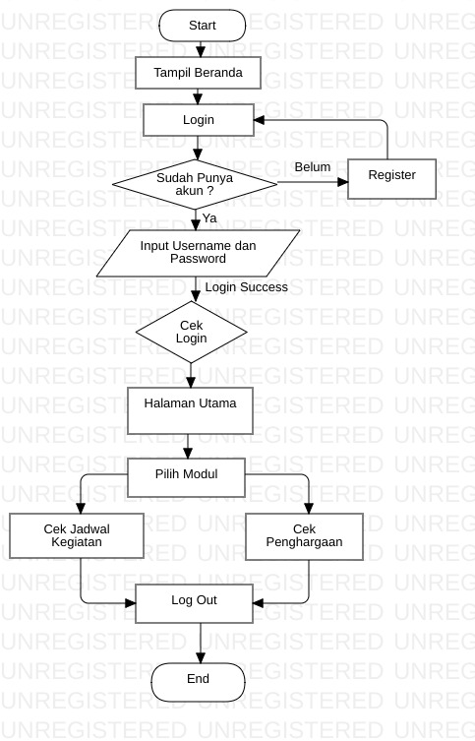

1. Gambar CFD Admin

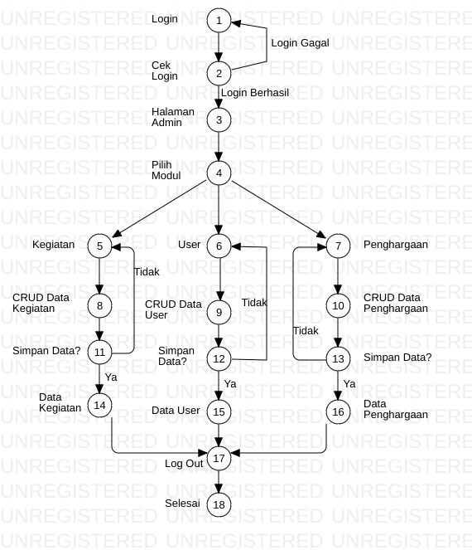

1. Gambar CFD User

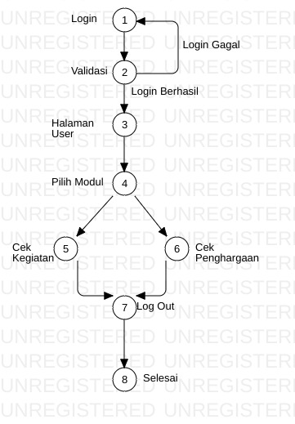

1. Gambar CFG Register

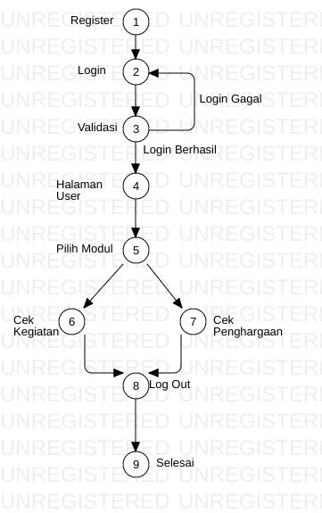

Basic Path

Flow Graph merupakan grafik yang digunakan untuk menggambarkan aliran kontrol dari sebuah program. Berbeda dengan flowchart, grafik pada flow graph tidak menggambarkan secara detail proses yang terjadi pada setiap blok notasi.

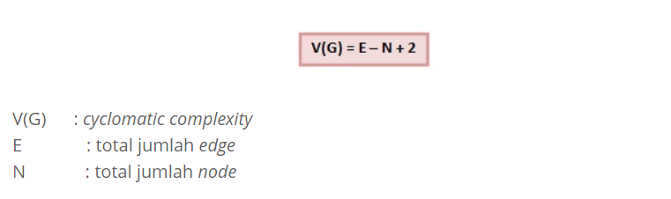

Hasil Basic Path

1. Hasil Admin

Jawab : V(G) = E – N + 2

= 23 – 18 + 2

= 5 + 2

= 7

1. Hasil User

Jawab : V(G) = E – N + 2

= 9 – 8 + 2

= 1+ 2

= 3

1. Hasil Register

Jawab : V(G) = E – N + 2

= 10 – 9 + 2

= 1+ 2

= 3

**Basic Alur Path**

Berdasarkan gambar flowchart diagram, maka alur-alur independent yang didapat :

1. **Basic Path Admin :**

Path 1 : 1-2-3-4-5-8-11-14-17-18

Path 2 : 1-2-1-2-3-4-5-8-11-14-17-18

Path 3 : 1-2-3-4-5-8-11-5-8-11-14-17-18

Path 4 : 1-2-3-4-6-9-12-15-17-18

Path 5 : 1-2-3-4-6-9-12-6-9-12-15-17-18

Path 6 : 1-2-3-4-7-10-13-16-17-18

Path 7 : 1-2-3-4-7-10-13-7-10-13-16-17-18

1. **Basic Path User**

Path 1 : 1-2-3-4-5-7-8

Path 2 : 1-2-1-2-3-4-5-7-8

Path 3 : 1-2-3-4-6-7-8

1. **Basic Path Register**

Path 1 : 1-2-3-4-5-7-8-9

Path 2 : 1-2-3-2-3-4-5-7-8-9

Path 3 : 1-2-3-4-5-6-7-8-9

1. **BlackBox**
2. **Boundary Value Analysis (BVA).**
3. Table Users

|  |  |  |  |  |
| --- | --- | --- | --- | --- |
| Nama Kolom | Invalid | Valid | Invalid | Valid |
| nama | 0 character | 5 character | 31 character | 30 character |
| email | 0 character | 5 character | 21 character | 20 caharacter |
| password | 0 character | 5 character | 16 character | 15 character |

1. Table Anggota

|  |  |  |  |  |
| --- | --- | --- | --- | --- |
| Nama Kolom | Invalid | Valid | Invalid | Valid |
| Nama | 0 character | 1 character | 31 character | 30 character |
| Asal Sekolah | 0 character | 1 character | 26 character | 25 character |
| Tanggal Lahir | 0 character | 1 character | 26 character | 25 character |
| Tempat Lahir | 0 character | 1 characcter | 21 character | 20 character |
| Agama | 0 character | 1 character | 16 character | 15 character |
| Foto | 0 character | 1 character | 26 character | 25 character |

1. Table Kegiatan

|  |  |  |  |  |
| --- | --- | --- | --- | --- |
| Nama Kolom | Invalid | Valid | Invalid | Valid |
| Nama Kegiatan | 0 character | 1 character | 26 character | 25 character |
| Tanggal Kegiatan | 0 character | 1 character | 16 character | 15 character |

1. Table Penghargaan

|  |  |  |  |  |
| --- | --- | --- | --- | --- |
| Nama Kolom | Invalid | Valid | Invalid | Valid |
| Nama Penghargaan | 0 character | 1 character | 26 character | 25 character |
| Foto | 0 character | 1 character | 26 character | 25 character |

1. **Tabel Kebenaran**

Pada bagian tabel kebenaran ini kita akan melihat pada bagian mana sebuah form tersebut dapat diproses dengan benar.

1. Validasi User

|  |  |  |  |  |
| --- | --- | --- | --- | --- |
| Nama | F | F | F | T |
| Email | F | F | T | T |
| Password | F | T | T | T |
| Pengumuman | Error | Error | Error | Benar |